Like most food, doughnuts taste even better when you’re camping. Here’s a simple recipe to cook fresh doughnuts on your next outing.

WHAT YOU’LL NEED

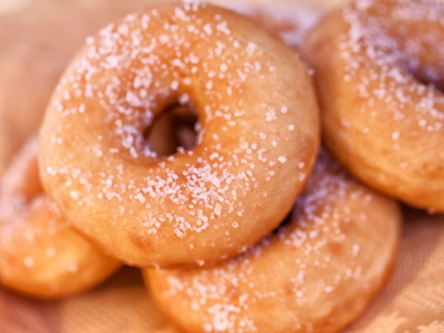

* 1 large can refrigerated buttermilk biscuits. Pillsbury Grands! Homestyle Buttermilk Biscuits or the equivalent work well. Avoid using “flaky” type biscuits.
* Vegetable oil
* Frying pan or Dutch oven
* ½ cup sugar
* ½ teaspoon cinnamon
* ½ cup confectioners or powdered sugar
* 2 lunch-size brown paper bags

WHAT YOU’LL DO

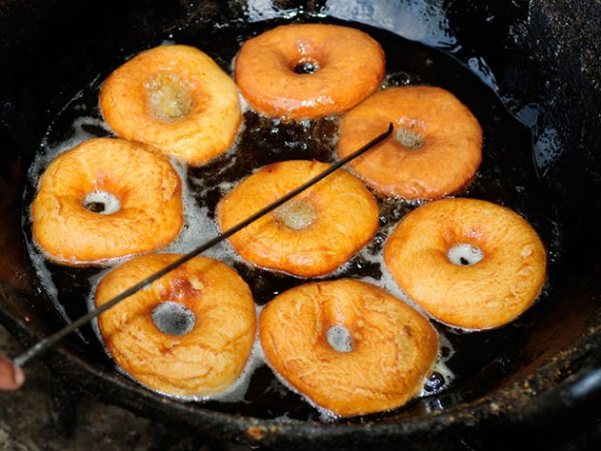

**SAFETY FIRST! Hot oil can splatter, burn or catch fire, so please ask an adult for help before trying this recipe.**

1. Separate the refrigerated biscuits.

2. Use a knife to cut a hole in each biscuit. You can also use the cap from the vegetable oil for perfect circles.

3. Heat about 2 inches of vegetable oil in a frying pan or Dutch oven and add as many biscuits as will fit. The hot oil can splatter, so be very careful!

4. Fry the biscuits for a few minutes, flipping them over with a fork or tongs when they are golden brown.

5. When the doughnuts are done, remove them from the pan and put them on a paper towel to soak up excess oil.

6. For cinnamon-covered doughnuts, combine the sugar and cinnamon in a paper bag. Add the doughnuts and shake well until the doughnuts are covered.

7. For powdered sugar doughnuts, put the confectioners sugar in a paper bag. Add the doughnuts and shake well until the doughnuts are covered. This works best if the doughnuts are still warm.

8. Remove doughnuts from bags and enjoy.

9. Don’t forget to cook the doughnut holes, too!